Latihan Modul 3

* {/\* Latihan 3.1 \*/}
* Source Code

import React, { Component } from 'react';

import {

StyleSheet,

View,

TextInput,

} from 'react-native';

export default class ContohTextInput extends Component{

render(){

return(

<View>

<TextInput placeholder="Masukkan Email anda"/>

</View>

)

}

}

* Tampilan

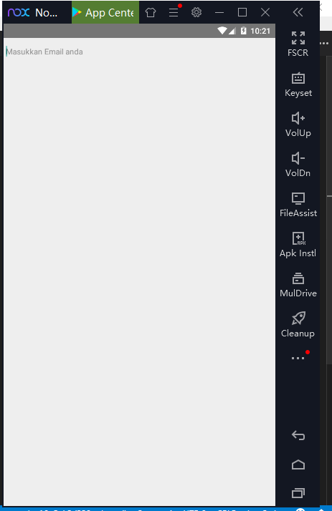

* {/\* Latihan 3.2 \*/}
* Source Code

import React, { Component } from 'react';

import {

StyleSheet,

View,

TextInput,

} from 'react-native';

export default class ContohTextInput extends Component{

render(){

return(

<View style={styles.container}>

<TextInput placeholder="Masukkan Email anda" style={styles.input} placeholderTextColor="rgba(0,0,0,0.3)"/>

</View>

)

}

}

const styles = StyleSheet.create({

container: {

padding: 10,

textAlign: 'center',

margin: 10

},

input: {

height: 40,

borderBottomWidth: 1,

borderColor: '#fcfcfc',

backgroundColor: 'rgba(0,0,0,0.1)',

color: '#444',

marginBottom: 10

}

})

* Tampilan

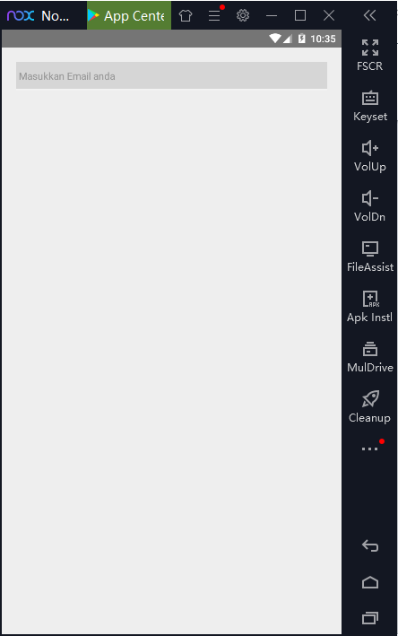

* **{/\* Latihan 3.3 \*/}**
* Source Code

import React, { Component } from 'react';

import {

StyleSheet,

View,

TextInput,

} from 'react-native';

export default class ContohTextInput extends Component{

render(){

return(

<View style={styles.container}>

<TextInput

placeholder="Masukkan Email anda"

style={styles.input}

placeholderTextColor="rgba(0,0,0,0.3)"

returnKeyType="next"

/>

</View>

)

}

}

* Tampilan

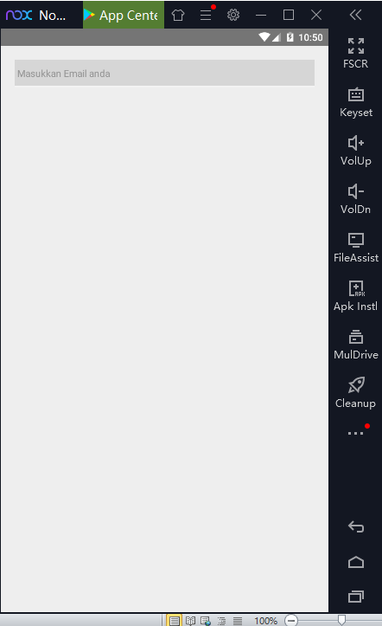

* {/\* Latihan 3.4 \*/}
* Source Code

import React, { Component } from 'react';

import {

StyleSheet,

View,

TextInput,

} from 'react-native';

export default class ContohTextInput extends Component{

render(){

return(

<View style={styles.container}>

<TextInput

placeholder="Masukkan Email anda.."

style={styles.input}

placeholderTextColor="rgba(0,0,0,0.3)"

returnKeyType="next"

onSubmitEditing={()=> this.inputPassword.focus()}

/>

<TextInput

placeholder="Masukkan Password anda.."

style={styles.input}

placeholderTextColor="rgba(0,0,0,0.3)"

returnKeyType="go"

ref={(input)=>this.inputPassword = input}

secureTextEntry

/>

</View>

)

}

}

const styles = StyleSheet.create({

container: {

padding: 10,

textAlign: 'center',

margin: 10

},

input: {

height: 40,

borderBottomWidth: 1,

borderColor: '#fcfcfc',

backgroundColor: 'rgba(0,0,0,0.1)',

color: '#444',

marginBottom: 10

}

})

* Tampilan

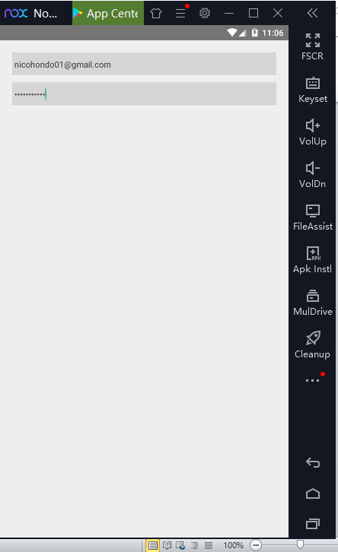

* {/\* Latihan 3.5 \*/}
* Source Code

import React, { Component } from 'react';

import {

StyleSheet,

View,

TextInput,

} from 'react-native';

export default class ContohTextInput extends Component{

render(){

return(

<View style={styles.container}>

<TextInput

placeholder="Masukkan Email anda.."

style={styles.input}

placeholderTextColor="rgba(0,0,0,0.3)"

returnKeyType="next"

onSubmitEditing={()=> this.inputPassword.focus()}

keyboardType="email-address"

/>

<TextInput

placeholder="Masukkan Password anda.."

style={styles.input}

placeholderTextColor="rgba(0,0,0,0.3)"

returnKeyType="go"

ref={(input)=>this.inputPassword = input}

secureTextEntry

/>

</View>

)

}

}

Note : Pada Emulator Nox, tidak bisa ditampilkan soft keyboard. Jadi tidak dapat diketahui apakah textInput email keyboard nya bertype email-address atau tidak, dikarenakan soft keyboard pada emulator tidak bisa tampil.

* Tampilan

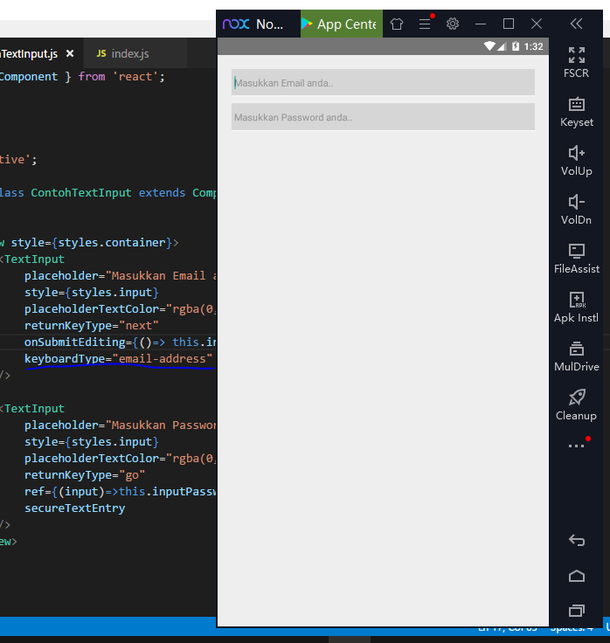

* {/\* Latihan 3.6 \*/}
* Source Code

import React, { Component } from 'react';

import {

StyleSheet,

View,

TextInput,

} from 'react-native';

export default class ContohTextInput extends Component{

constructor(props){

super(props)

this.state = {

email : '',

password : ''

}

}

render(){

return(

<View style={styles.container}>

<TextInput

placeholder="Masukkan Email anda.."

style={styles.input}

placeholderTextColor="rgba(0,0,0,0.3)"

returnKeyType="next"

onSubmitEditing={()=> this.inputPassword.focus()}

keyboardType="email-address"

onChangeText={(value)=>this.setState({email:value})}

autoCapitalize="none"

/>

<TextInput

placeholder="Masukkan Password anda.."

style={styles.input}

placeholderTextColor="rgba(0,0,0,0.3)"

returnKeyType="go"

ref={(input)=>this.inputPassword = input}

secureTextEntry

onChangeText={(value)=> this.setState({password :value})}

autoCapitalize="none"

/>

</View>

)

}

}

const styles = StyleSheet.create({

container: {

padding: 10,

textAlign: 'center',

margin: 10

},

input: {

height: 40,

borderBottomWidth: 1,

borderColor: '#fcfcfc',

backgroundColor: 'rgba(0,0,0,0.1)',

color: '#444',

marginBottom: 10

}

})

* Tampilan

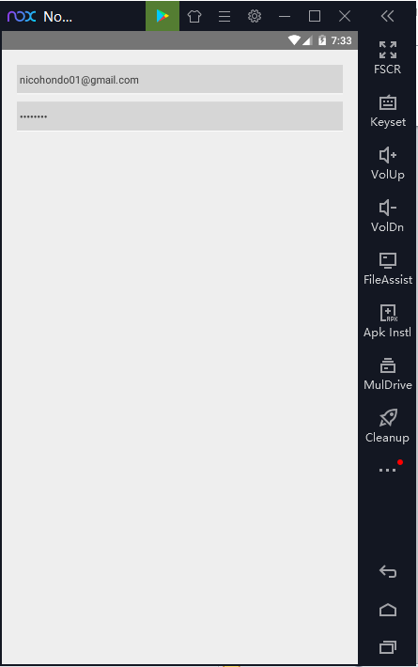

{/\* Tugas 3. 1 \*/}

* Source Code

import React, { Component } from 'react';

import {

StyleSheet,

View,

TextInput,

TouchableOpacity,

Button,

Text,

Image

} from 'react-native';

import { darkcyan } from 'color-name';

import foto from '.././assets/Images/react.png';

export default class ContohTextInput extends Component{

constructor(props){

super(props)

this.state = {

email : '',

password : ''

}

}

render(){

return(

<View style={styles.all}>

<Image source={foto} style={{width: 130, height: 130, borderRadius: 80, marginBottom: 5}}/>

<Text style={{fontSize: 30, fontWeight: "bold", marginBottom: 30}}>REACT</Text>

<View style={styles.container}>

<TextInput

placeholder="Masukkan Email anda.."

style={styles.input}

placeholderTextColor="rgba(0,0,0,0.3)"

returnKeyType="next"

onSubmitEditing={()=> this.inputPassword.focus()}

keyboardType="email-address"

onChangeText={(value)=> this.setState({email : value})}

autoCapitalize="none"

/>

<TextInput

placeholder="Masukkan Password anda.."

style={styles.input}

placeholderTextColor="rgba(0,0,0,0.3)"

returnKeyType="go"

ref={(input)=>this.inputPassword = input}

secureTextEntry

onChangeText={(value)=> this.setState({password : value})}

autoCapitalize="none"

/>

<TextInput

placeholder="Masukkan Ulang Password anda.."

style={styles.input}

placeholderTextColor="rgba(0,0,0,0.3)"

returnKeyType="go"

ref={(input)=>this.inputPassword = input}

secureTextEntry

onChangeText={(value)=> this.setState({password : value})}

autoCapitalize="none"

/>

</View>

<TouchableOpacity style={styles.sum} >

<Button

title="Masuk →"

color="#556B2F"

onPress={() => this.setState({ instruksi: true })}

/>

</TouchableOpacity>

</View>

)

}

}

const styles = StyleSheet.create({

all: {

backgroundColor: 'darkcyan',

flex: 1,

justifyContent: 'center',

alignItems : 'center'

},

container: {

padding: 10,

textAlign: 'center',

},

input: {

height: 40,

borderBottomWidth: 1,

borderColor: '#fcfcfc',

backgroundColor: 'rgba(0,0,0,0.3)',

color: '#444',

width: 380,

marginBottom: 10

},

sum: {

width: 170

}

})

* Tampilan
* Keseluruhan

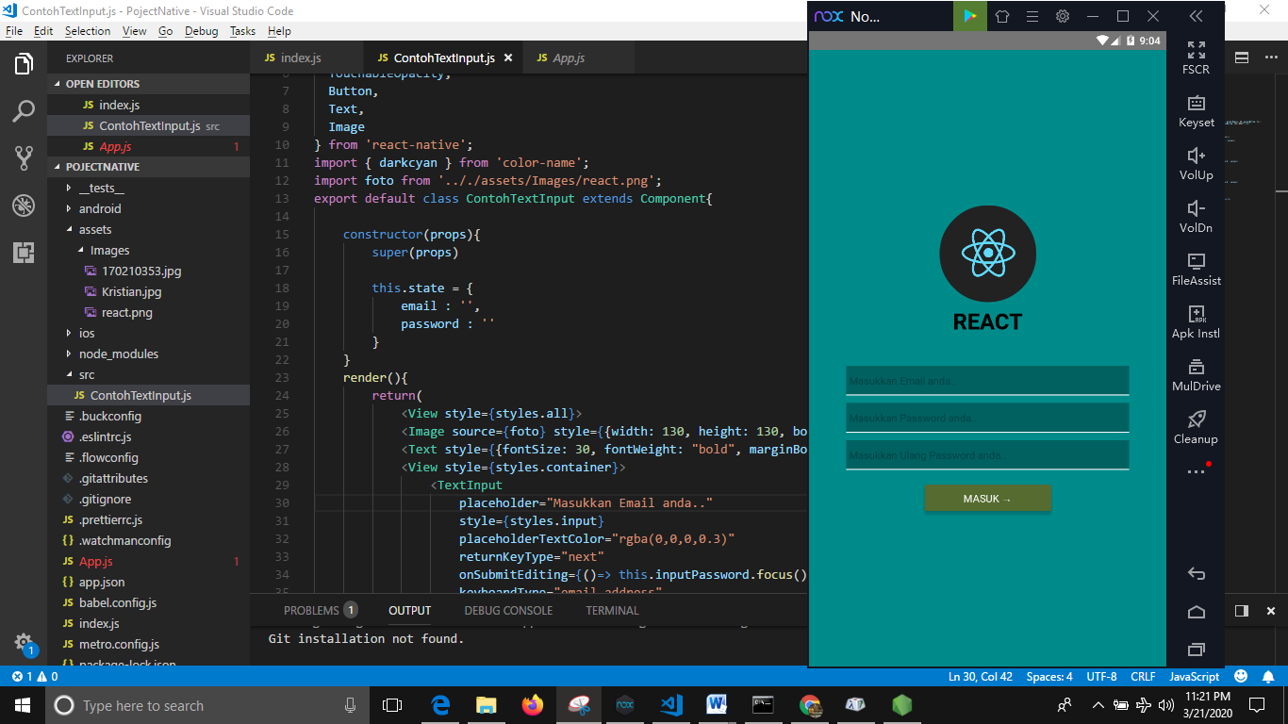

* Emulator

